

DBMS Project (6th Semester)

Group members -

Pallav Dubey (CSE/19054/481)

Kumar Saurabh (CSE/19043/470)

Cooking Recipe Database

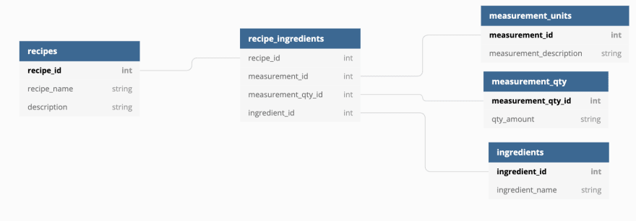

Recipes Table (primary key Recipe_id)

recipe_id int
recipe_name string
description string

Recipe_ingredients (primary key measurement_id)

recipe_id int
measurement_id int
measurement_qty_id int
ingredient_id int

Measurement_units (primary key measurement_id)

measurement_id int
measurement_description string

Measurement_qty (primary key measurement_qty_id)

measurement_qty_id int
qty_amount string

Ingredients (primary key ingredients_id)

ingredients_id int
ingredient_name string

